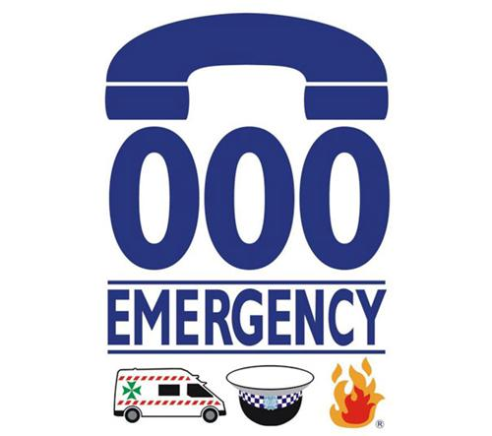

uction
Emergency and Disaster Management Plans
One Life Foundation
- Introduction
This Emergency Preparedness and Response Plan is provided to enable One Life Foundation to manage most emergencies.
An emergency is an unexpected event of a serious nature, which demands immediate action, can arise as either an incident such as an accident or dangerous event in the workplace, the result of severe climatic conditions, natural disaster or as a security threat.
The scope of this Emergency Preparedness and Response Plan covers such events as they may affect One Life Foundation employees, subcontractors, clients and the public.
- Type of Emergencies

The following, although not exhaustive, illustrates the type of emergencies that may confront One Life Foundation workers and participants:
Accidents caused by a person or as a result of a person’s actions causing injury which may be minor, major or critical.
Dangerous events include:
- Collapse, failure/malfunction of or damage to car and equipment.
- Implosion, explosion or fire.
- Hazardous substances or dangerous goods.
- Severe climatic conditions or natural disasters e.g. floods.
- Aggressive behaviour; and
- Security threats e.g. criminal activity, vandalism or bomb threats
- Should there be any type of pandemic emergency, refer to the COVID-19 Response Plan

- Planning for Emergencies
One Life Foundation must establish and maintain site-specific arrangements using the following guidelines:
- Prepare an Emergency Response Plan including a plan indicating assembly point and complete the Emergency Services Contacts and the Emergency Contacts Site Map;
- Include an effective method of ensuring that visitors are accounted for. Include and maintain an up-to-date daily list(s) of all personnel in the office including visitors.
- Include an effective “Emergency Alert” system (air-horn, alarm, etc.).
- Establish and maintain a safe and effective evacuation route and assembly locations.
- Include appropriate and adequate firefighting equipment (extinguishers, alarms, signage).
- Establish a reliable communications system (radios, mobile phones, etc.).
- Appoint key personnel to take control during an emergency.
- Instruct workplace personnel in these procedures and ensure that they are fully aware of them.
- Maintain training records of all emergency training.
- Emergency escape drills must be conducted at least once per quarter and more frequently for higher-risk situations, for example in areas where hot works are ongoing.
- Where practicable, drills should be conducted in conjunction with local emergency services or a suitably qualified fire contractor.
- Establish and maintain appropriate first aid resources and training.
- Identify local Doctors/Medical Centres.
- Identify and liaise with the local Emergency Services.

- Responsibilities
- Managing Director or Operations Manager
The Managing Director or Operations Manager must:
- Ensure that the Emergency Management Team, (Chief Warden and Area Wardens) are identified and selected. Note that first aid personnel, whilst part of the Emergency Management Team, are selected by different criteria and are therefore not discussed here.
- The Emergency Management Team members should meet the following criteria:
  - Be physically capable and be able to communicate clearly.
  - Possess leadership qualities and can exercise authority.
  - Demonstrate good judgement and decision-making skills, with the ability to remain calm under pressure.
- Ensure that all employees are trained on the action required in an emergency.
- The Managing Director or Operations Manager shall be responsible for external communication about accidents and/or incidents, as appropriate.

- Supervisors:
Supervisors must:
- Ensure that all emergency exits are identified and maintained clear and unobstructed.
- Ensure all employees (particularly new employees) under their control are aware of the Emergency Management Plan and can identify the assembly areas and the relevant Emergency Management Team members.
- Ensure all employees under their control participate in training and in emergency evacuation drills when requested.
- Ensure that all Emergency equipment, signs, plans etc. in their area relating to the Emergency Management Plan are maintained in good condition.
- Employees:
Employees must:
- Participate in training, emergency evacuation drills and other matters relating to the Emergency Management Plan as requested.
- Report unsafe conditions in the workplace relating to Emergency equipment, fire extinguishers, etc.
- Move to and remain at the Emergency Assembly area in the event of an Emergency or exercise drill.
- Ensure that, as far as practicable, equipment is left in a safe condition before leaving the workplace in an emergency, (i.e. welding/cutting equipment turned off, machines shut down, etc.).
- Fire Warden:
Fire Warden must
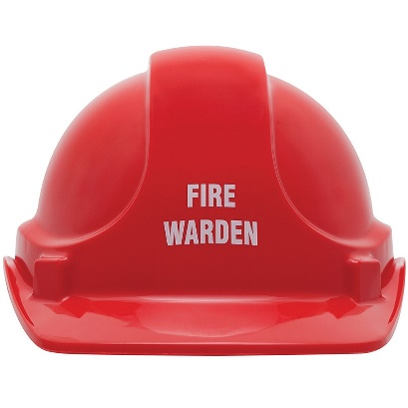
- Be familiar with the layout of your area(s) of responsibility.
- Understand the operation of the communication systems (if applicable).
- Know the location of any staff who have a permanent disability and discuss evacuation procedures/options with them, in conjunction with the other Wardens.
- Understand the operation of and correct use of Fire Extinguishers.
- Know the Emergency Alarms in your Building.
- Know the methods of raising the alarm.
- Know the location of the External Assembly Area(s).
- Familiarise yourself with your role and the procedures for all emergencies.
- Always prioritise LIFE SAFETY first.
At the time of Emergency
- Ensure that the appropriate emergency service has been notified.
- If necessary, initiate evacuation and control entry to the affected areas.
- Record the relevant details in Form03. Improvement Report Form.
- Brief the Emergency Services personnel upon arrival on the type, scope and location of the Emergency and the status of the evacuation therefore might need to, act on the Officer’s instructions.

- Mock Emergency Evacuations
Mock emergency evacuations will take place every 6 months or at the Management Teams discretion using Form81. Emergency Drill Reporting form
The effectiveness of evacuations, both planned and unplanned, will be evaluated and corrective actions are taken where necessary.
Mock evacuation scenarios are to be rotated between the following scenarios:
- Fire Emergency
- Medical Emergency
- Unplanned gas omissions/Hazardous Substance
- Electrical Hazard
- Environmental Emergency

Emergency Contact Numbers
Police |  |  | 
Fire
Ambulance
Key Personnel (24 Hr. Contact)
Fire Warden:
First Aider:
Utilities
Electricity Authority: |  | [insert name] |  | [Insert phone #]
Water Authority: |  | [insert name] |  | [Insert phone #]
Gas Authority: |  | [insert name] |  | [Insert phone #]
Nearby Facilities
[Insert name of nearest medical centre]  [insert operating hrs.] | [Insert address of nearest medical centre] |  |  | [Insert phone #]
[Insert name of nearest public hospital]  [insert Accident & Emergency hrs.] | [Insert address of nearest public hospital] |  |  | [Insert phone #]

- 6. Action in an event of a Fire
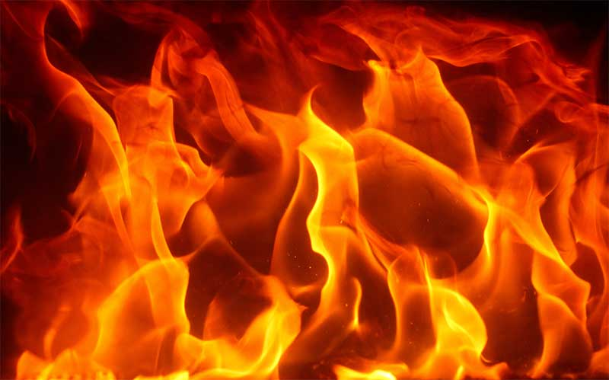

- Using Fire Extinguishers
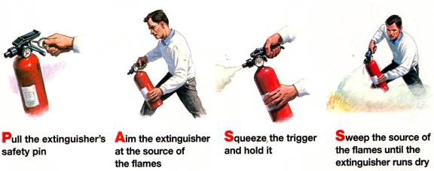
- Using Fire Hose Reels
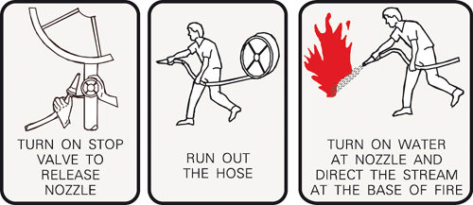
- Fire Extinguisher Colour Codes
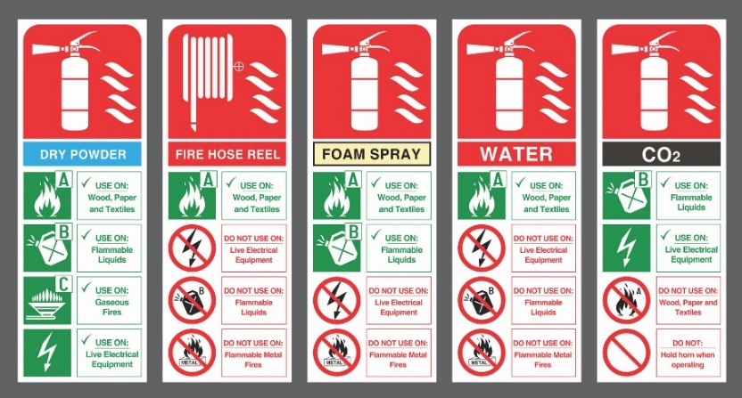

The following precautions should be taken:
- Ensure that entrances to buildings are unlocked during working hours and that there are sufficient and effective means of escape.
- Effective means of escape must be provided and maintained which are suitable for the number and specific needs of all people likely to need to use them.
- Emergency escape routes must be easily identifiable, adequate width, kept free from obstruction and not used for storage.
- Sufficient firefighting equipment, such as fire extinguishers will be provided and be appropriate for the site and the works underway and will comply with any applicable codes or regulations.
- All firefighting equipment must be correctly located, readily accessible, unobstructed, clearly signed and have clear instructions on its correct use.
- All firefighting equipment must be checked and serviced regularly, by a competent person in accordance with the manufacturer’s guidelines. If there are any applicable codes or regulations these results will need to be recorded.
- A weekly documented check must be carried out on all firefighting equipment to ensure they have not been damaged, discharged or gone missing.
- The type of extinguishers provided will match the firefighting requirements for the materials, plant and equipment to be used on-site;
- CO2 or dry chemical fire extinguishers are used on electrical fires. Minimum of one (1) on-site at all times;
- Spark arrestors will be used on all plant and equipment-producing sparks. Due care will be taken to prevent equipment from starting fires;
- Sufficient fire wardens must be appointed and trained in Emergency procedures, including the need to check areas are clear of people in an evacuation and basic firefighting techniques if appropriate (e.g., how to use an extinguisher).
Clear instructions must be provided to all people, including workers and visitors, detailing:
- Emergency warning systems
- Evacuation procedures
- Identity, contact details and role of fire wardens (if appointed), and
- Assembly areas in the event of an emergency.

DO NOT
- Panic
- Run
- Collect personal belongings or Company documentation
- Don’t talk to media
DO
- Proceed in an orderly manner to the nearest safe exit.
- Proceed to the Emergency Assembly Point and wait until otherwise directed by a Fire Warden.
- Receptionist to take Visitor and Employees Sign-In Register.
- Headcount will be conducted once at the Emergency Assembly Point.
- Wait together until advised it is safe to re-enter the yard or office.

- Hazardous Substances / Dangerous Goods
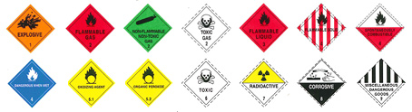

The following actions will be undertaken in the event of a Chemical Release:
- Any spill that escapes the site onto public land or into the storm-water system is considered to be a major spill and has already impacted the environment.
- Any spill that can be cleaned up on a hard surface like concrete or bitumen is not considered to have impacted the environment.
- Spill kits will be provided and maintained by any contractor using any chemical that could impact the environment.
- Contractors are responsible to clean up any spills they have caused and disposing of the waste using a licensed waste disposal contractor as applicable.
- Chemical releases that result in dangerous fumes will require an evacuation of the affected area.
- Persons cleaning up such a spill should evaluate the danger using the information on the MSDS before entering the area to clean up.
- It may be necessary to leave the site evacuated and call emergency services to clean up if the use of breathing apparatus is required to do so.
- See the notification sections below relating to the requirement to notify any authority.
- Storing Incompatible Hazardous Chemicals

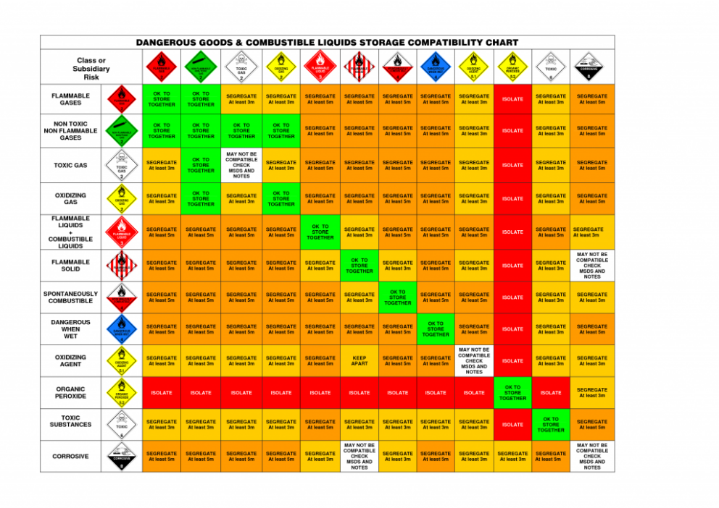

- Gas Leak
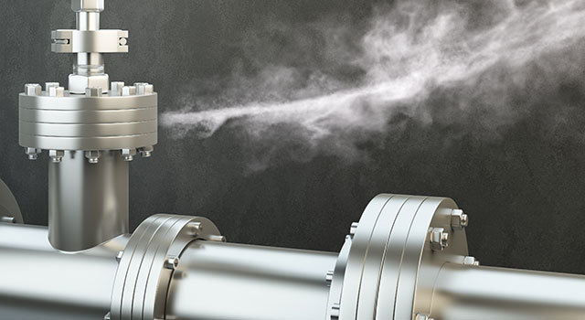

- Bomb Threat
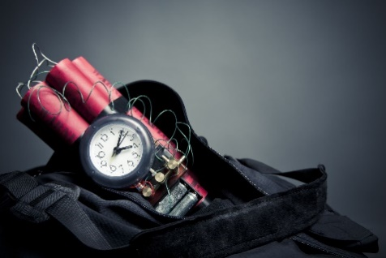

- Medical Emergency


- Flood Emergency

- Storm Emergency

- Aggressive Behaviour
The following is a set of guidelines to be adopted when faced with a person exhibiting threatening or aggressive behaviour.
Remain Calm
- Treat the person as normal;
- Answer questions politely but do not debate the issue;
- Do not raise your voice or make sudden movements; and
- Do not tell half-truths or attempt to trick the aggressor.

Call for assistance
- At the earliest opportunity call for assistance;
- Attract the attention of a co-worker;
- If possible, excuse yourself and explain that you will have the Site Manager discuss matters with them to resolve the situation;
- In other circumstances, attempt to use the phone to contact the Site Manager; and
- If possible, ensure that a second member of staff is present to act as a witness or render physical assistance if required.
Keep out of Reach
- If the aggressor is, or becomes violent, keep out of reach;
- Keep a safe distance – at least two arm’s length;
- Do not converge on the offender; and
- Defend yourself when there is no other option.
Don’t antagonise
- Move away from the aggressor, do not stand around the area if not required, or there is no need to converse with the aggressor;
- Do not abuse or ridicule the aggressor;
- Do not detain the aggressor if they wish to leave; and
- Do not block the aggressor’s exit.

Report the Incident
- Notify your Supervisor after being confronted by an aggressive person; and
- Your Supervisor may organise counselling if needed.

Notify Police when:
- Damage to property has occurred;
- People have been assaulted; and
- A threat was made with a weapon.
Incidents involving injury to a person
As indicated previously incidents that can cause injury are either caused by the actions of the person suffering the injury or alternative caused by the actions of another person and/or the involvement of plant and equipment.
Minor Incident
A minor incident is one where the person involved suffers an injury that will only require first-aid attention in the place.
The injured person will:
- Report the injury to the Manager and if readily available the First Aid Attendant.

The Manager will:
- Locate the First Aid Attendant if not already notified; and
- In consultation with the First Aid Attendant decide as to whether treatment over and above First Aid is required
- Contact the appropriate provider if treatment is needed (000 or local medical clinic)
- Once first aid is given, ensure the incident is recorded.

First Aid Attendant
- Administrate First Aid assistance; and
- Ensure the Incident Report is filled in and handed back to the Manager.
Major or Catastrophic Incident
Major or catastrophic incidents are ones where the person injured requires medical attention from a doctor or hospital and in the latter the injury results in death or permanent impairment.
Incident witness:
- Give First Aid if possible; and
- Notify the Manager.

The Manager will:
- Locate and notify the First Aid Attendant and if applicable, Fire Warden;
- Ensure all work is stopped in the area and isolate the area if necessary
- Secure the area to preserve evidence whilst ensuring the safety and care of the injured;
- Ensure other persons do not endanger themselves in attempts to assist or rescue;
- Initiate and maintain communication with applicable Emergency Services and give clear information to ensure that they are guided to the scene of the incident.
- Notify the relevant Manager and any applicable person or agency (e.g. Client, local council, WorkSafe, Fire Brigade, Police, Ambulance).
- Ensure the injury is recorded in the incident report.

- Motor Vehicle Accidents
There are often very high human consequences associated with transportation accidents, such as deaths and injuries. Other dangers present themselves as a consequence of MVA’s like fuel and gas fires/explosions, fuel leaks, HAZMAT, electricity and sharps hazards.
Recommended evacuation distances from various sized gas containers are listed in the table below.
Threat Description |  | LPG Mass/Volume¹ | Fireball Diameter² | Safe Distance³
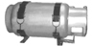 | Large LPG Tank | 45 kg/95 l | 21 m | 84 m
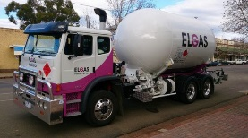 | Small LPG Truck | 3,630 kg/7,570 l | 89 m | 356 m
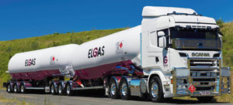 | Semi tanker LPG | 18,144 kg/37,850 l | 152 m | 608 m
The Primary Rescue service are listed below for the following areas:
- Fire brigade contact 000
- Ambulance contact 000
Immediate Actions
Protect your own life
- In the absence of any direction, use your best judgement to remove yourself from danger.
Protect the life of your participants and colleagues
- Ring ‘000’ and Safety and Security 6773 2099.
- Alert others in your immediate area to the danger, and act together for the benefit of everyone.
Response
- Ascertain if any person/s injured – if yes, request Ambulance and render First Aid if practicable.
- Determine if vehicle/s pose a hazard to persons nearby (e.g. leaking fuel) – if yes, request appropriate emergency services and evacuate persons from the immediate danger area.
- If no person is injured and no danger exists, determine if the vehicle/s poses an obstruction to normal traffic flow. If yes, request driver/s to move vehicles off the road (e.g. into the car park) – if the vehicle is unable to be moved, request the driver to immediately obtain tow truck assistance.
- Confirm if the driver/s requires Police to be called (if persons are injured, Police must attend). If there has been a fatality then all evidence must be left in place for police investigations.
- Even if nobody is hurt, you have to exchange details with the other driver or the owner of any property that is damaged. It is an offence to leave the scene of a vehicle accident without doing this.
- If the police attend the accident scene, they will interview the people involved and any other witnesses. Police may charge the drivers with breaking the road laws.
- If someone causes a crash, they are responsible for any damage they cause.
- You must report the accident to the police if:
- anyone’s property is damaged
- the other person involved in the accident does not stop or refuses to give their details.
- Police may not attend the accident scene unless someone has been injured. If police attend the scene, they will usually test drivers for alcohol or other drugs. It is a serious offence to refuse this test

